GESTURE RECOGNITION SYSTEM

Aditya Krishna   
Department: Computer Science & Engineering KIET Group of institution Ghaziabad,  
 aditya.1923cs1178@kiet.edu

Aman Goswami  
Department: Computer Science & Engineering  
*KIET Group of institution Ghaziabad,INDIA,*

Dilkeshwar Pandey   
 Department of Computer Science & Engineering  
*KIET Group of Institutions,,*Ghaziabad, INDIA  
Dilkeshwar.pandey@kiet.edu Akshay Kumar  
Department: Computer Science & Engineering, KIET Group of Institution Ghaziabad, INDIA   
 akshay.1923cs1078@kiet.edu

***Abstract*—** **In the age of machine learning, hand gestures and recognition technology play a big role between humans and machines. It gives humans the ability to control machines using natural language. In this paper, we show a GESTURE RECOGNITION SYSTEM that lets us control machines with our hands or faces.** **In order to extract relevant features from input data, the system makes use of deep learning models, such as convolutional neural networks (CNNs) and recurrent neural networks (RNNs). It is able to analyze information in both the visual and depth dimensions, allowing it to accurately capture the nuances of hand motions and spatial connections. The system takes a multi-modal approach, which involves combining data from a variety of various input sources, in order to guarantee that it is able to recognize a broad variety of motions. Transfer learning methods are used in its training, which is done on a vast dataset of annotated gestures. This allows it to adapt to unique user preferences as well as innovative gestures.**

# INTRODUCTION

. **Gesture recognition** is a combination of human gestures and a mathematical Algorithm by which we can achieve mechanical operation. Currently, Gesture recognition majorly focuses on hand and facial gesture recognition. The primary application of gesture recognition are manifold, TUI(Touchless User Interface), and Virtual reality.

**Gesture Recognition System:-** In GRS, a camera detects human body movement (such as head and hand movement) and transmits the information to a computer, which uses gesture recognition as input and manages the hardware or software recognition. Gesture recognition can be used to recognize speech expressions and to communicate with computers using sign language. Hand Gesture Recognition, Face Gesture Recognition, and Body Gesture Recognition are all ways that gestures can be read..

The Gesture Recognition system creates the combination of several stages such as Data Acquisition, Data Modelling, Feature Extraction, and recognition stage.

Key problems with hand motion detection systems are listed as the difficulties of gesture systems. The main goal of making a hand gesture recognition system is to make it possible for people and computers to engage in a normal way. The movements that are recognised can be used to run a robot or send important information. The hard part of gesture contact is figuring out how to make hand movements that a machine can read and understand. Depending on the type of gesture, the segmentation process is different. For a dynamic gesture, the hand gesture needs to be found and tracked. For a static gesture, only the input image needs to be split. Key Points Extract After a good segmentation process, feature extraction works perfectly.

Gesture detection is the process of using human movements and a mathematical algorithm to make a machine work. Currently, Gesture recognition majorly focuses on-hand and facial gesture recognition. The primary application of gesture recognition are manifold, TUI(Touchless User Interface), and Virtual reality.

There is also a Subcategory of Hand gesture recognition which is Hand gesture recognition systems that use gloves and vision are also available.

In Glove based Hand Gesture Recognition we have to use Flex Sensors that capture the movement of all 5 fingers then we have to assign a task that we have to perform by the movement of a particular finger. Flex Sensor requires an input of 5-V and an output between 0-5V.

Vision-based hand recognition it uses one or more cameras to recognize hand movements in this we use various python libraries such as open cv, mediapipe and pyautogui.

# Working

The work is founded on the vision-based hand-recognition System As the recognition with any machine learning technique caused the variability in the problem to solve this we have to take some assumptions.

* We have to use a single-color camera.
* Users have to directly interact with the camera which the user should have to present in front of the camera.
* If you want to increase how well the device functions, training is an absolute necessity.
* The hand should be still and should not be rotated when the image is captured by the camera.

**Hardware Used in this project**

* Min processor Pentium-4th gen and Recommended intel core i3
* RAM at least 1GB
* Webcam
* Storage 12GB free space

**Software Used in this project**

* Windows XP,7,8,10,11
* VS- code editor
* Python 3
* Direct x11
* Python libraries Such as Open CV,mediapipe, and Pyautogui

**Implementation of Hand Gesture recognition system**

**The following steps are needed in order to perform a vision-based recognition system**

* First, we have to perform pre-processing and get the process imaged by the camera
* It is necessary for us to isolate characteristics from the processed image.
* Third, we have to assign the work to each gesture so we can perform real-time classification.

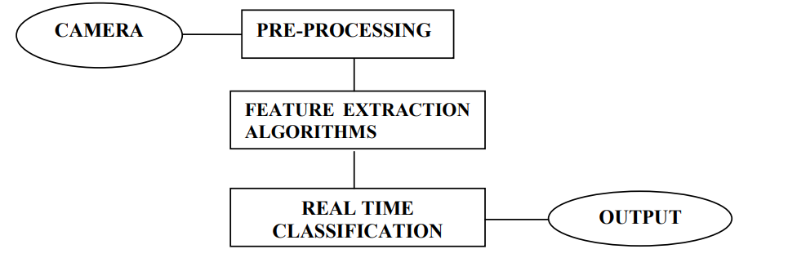

Fig 1

**Python libraries used to create a Gesture Recognition System**

* **OPEN-CV**: Open CV is short for "open source computer vision library." This is its full name. The implementation of the vision-based gesture recognition System requires the usage of open cv, which is essentially a free and open-source Python library.
* **Mediapipe:** mediapipe is developed by google it is a cross-platform service it provides ready-to-use machine learning solutions for hand gesture and recognition systems.
* **Pyautogui:** Pyautogui is a python package that is used to simulate the movement of the mouse cursor and also use as a clicking mechanism of The keyboard and mouse

**Features**

**1. Mouse cursors control Using hand gestures.**

A project that enables users to control the movement of the computer cursor using hand gestures is called mouse cursor control via hand gesture. This technology often employs a camera or other sensors to identify the user's hand's position and motions, which are subsequently converted into instructions for cursor movement.

The idea behind this project is to employ computer vision techniques to track the user's hand's location in real time. These algorithms are capable of recognizing a wide range of hand motions, including pointing, gripping, and waving, and translating them into equivalent movements of the cursor on the screen.

When compared to other systems, this one offers a more natural and intuitive way to control the cursor.

**2. Volume control by Using hand gestures.**

The hand gesture volume control is a system that enables users to adjust a device's volume using hand gestures, like a television or music player. Typically, sensors like cameras are used by the system to recognize and track hand movements, which are then converted into instructions for the device to change volume. On the basis of the user's gesture, computer vision algorithms are frequently utilized to follow the user's hand motions and determine the intended volume level. With no need for buttons or remote control, this method offers a simple and convenient way to regulate volume.

**3. Mouse using face gesture**

Users can move a computer cursor by using facial gestures thanks to a technique called "mouse control using face gestures." The user's face is often detected by a camera or other sensor, which tracks their facial expressions and converts them into instructions for cursor movement.

The purpose of this project is to make use of computer vision and face recognition algorithms in order to monitor and identify a variety of distinct facial expressions, such as eye blinking, eyebrow raising, and mouth opening. The movement of the cursor on the screen can then be controlled by these algorithms using the detected movements.

This system's benefit is that it offers a hands-free, more natural method of controlling the cursor than

.

# AREA OF APPLICATION OF GESTURE RECOGNITION SYSTEM

**Drone control**

Using gesture recognition technology we can control drones. it is one of the interesting applications in this field. We can use different hand sign to control the movement of the drone each sign have its unique command and meaning. for ex- Thumbs up means rise, Thumbs down means go downward, and so on.

**Number recognition**

Using this technology system recognizes meaningful gestures using the hand which has unique numbers in meaning.

**Television control**

Using Gesture recognition technology we can control the functionality of television using different hand signs we can change the channel, volume, etc

For ex-using thumbs up means increasing the volume, thumbs down to decrease the volume, thumbs right and left to change the channel, and so on.

**Advantages**

1- By gesture recognition, we can control the virtual environment.

2- Gesture recognition is Simple, easy, and fast to implement. And it can be applied in a real-time environment and to play gesture-applicable games.

3-This System easily recognized static and dynamic gestures.

4-Gesture recognition is used to control robots and many electronic appliances.

5-Gesture recognition is also used for security purposes for example in the Face lock System.

**Disadvantage**

1-Performance decreases with an increase in the distance.

2-Need high-quality hardware equipment to recognize the gesture correctly.

3- The applications are limited due to the constraints imposed by the system, such as the user having to hold their arm in a vertical position with their palm towards the camera in order for the camera to be clearly recognised.

**ISSUES**

1. Lighting Situations: Systems for recognizing hand gestures are sensitive to variations in lighting situations. The system's precision can be impacted by shadows, glare, and changes in ambient illumination.

2. Background Noise: The background noise in a scenario, such as other people or objects, might impair the accuracy of hand gesture detection systems. The hand gestures in the scene must be distinguishable by the system from other movements.

3. Hand Gesture Variations: Hand gestures can differ from person to person, and even the same person may make slightly different movements every time. A system for recognizing all hand gestures could be challenging to develop as a result.

4. Inadequate Training Data: Hand gesture recognition systems need a lot of training data in order to correctly identify hand motions. lacking in experience

## **Scope of study**

This study deals with the problem that arises during machine-human interaction. This is a very broad field of study in which we study different kinds of human machine interaction systems like using hand, face, etc. In gesture recognition, we study in three phases. The first one is preprocessing, the Second is feature extraction and the last is classification. So it is further studied in the above three phases. In the first phase, we separate out the hand or face from the background we can use special filters to remove noise and the edge of the hand is also detected after edge detection, we get the final shape of the handIn the second step, we look into the several ways that features may be extracted. Scaling, rotation, and translation are all used in the process of feature detection.

**Equations**

Systems for hand gesture identification classify gestures using a range of formulas and algorithms. Examples of formulas that can be applied in hand gesture recognition systems are given below:

Using the Histogram of Oriented Gradients (HOG) formula, the gradient of the picture is calculated for each pixel in both the x and y directions of the image.

The gradient magnitudes are binned into orientation histograms for each cell in the image using the Orientation Binning Formula.

The cell histograms are normalized using the normalization formula to lessen the impact of changing lighting conditions.

Convolutional Neural Networks (CNN): Convolution Formula: creates feature maps by convolutions the input image with a series of learned filters.

Downsampling the feature maps to lower their spatial resolution and extract the standout features is part of the pooling formula.

A variety of mathematical formulas and algorithms are used by gesture recognition systems to identify and categorize gestures. Examples of equations applied in gesture recognition systems are provided below:

Gesture recognition systems use a range of mathematical equations and algorithms to recognize and classify gestures. Here are some examples of equations used in gesture recognition systems:

**Convolutional Neural Networks (CNN):**

Convolution: H_mn = ∑i=0,k-1 ∑j=0,k-1 I_(m+i)(n+j) K_ij, where H_mn is the output feature map, I is the input image, K is the convolution kernel, and k is the kernel size.

Pooling: Y_(i,j) = max X_(2i+m,2j+n), where Y is the pooled output feature map, X is the input feature map, and m and n are the pooling window offsets.

Softmax: P_i = e^(z_i) / ∑j e^(z_j), where P_i is the probability of class i, z_i is the output of the final layer for class i, and j iterates over all classes.

**Dynamic Time Warping (DTW):**

Cost Matrix: C_ij = d(x_i, y_j), where C is the cost matrix, x and y are the sequences being compared, and d is the distance metric.

Accumulated Cost Matrix: D_ij = C_ij + min(D_(i-1)j, D_i(j-1), D_(i-1)(j-1)), where D is the accumulated cost matrix.

Backtracking: finds the optimal warping path through the accumulated cost matrix by starting at D_NN and following the minimum-cost path to D_11.

**Support Vector Machines (SVM):**

Decision Function: f(x) = sign(∑ α_i y_i K(x_i, x) + b), where f(x) is the decision function, α_i and y_i are the support vector parameters, K is the kernel function, x_i and x are the training and test examples, and b is the bias term.

Kernel Functions: linear: K(x, y) = x.y, polynomial: K(x, y) = (x.y + c)^d, radial basis function: K(x, y) = e^(-γ ||x-y||^2), where c, d, and γ are hyperparameters.

Shape Recognition:

**Convex Hull**: H = ConvexHull(P), where H is the set of vertices of the convex hull, and P is the set of points in the hand region.

Hand Geometry: length = √((x_2 - x_1)^2 + (y_2 - y_1)^2), width = √((x_4 - x_3)^2 + (y_4 - y_3)^2), aspect ratio = length / width.

# Figures

1. In fig 2 and 3. Image is showing the functioning of the virtual mouse When the index finger and the thumb come closer then the mouse cursor start to move from its initial position if we make contact between the index finger and thumb then the clicking mechanism of the mouse starts working.

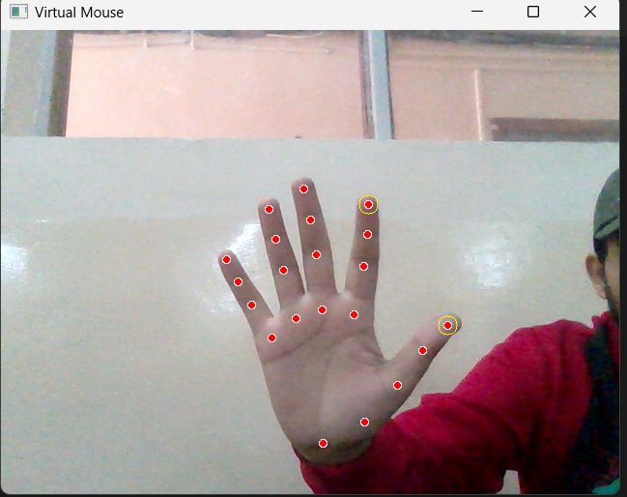

Fig 2

## 

Fig 3

**2.** Volume control by Using hand gestures.

The hand gesture volume control is a system that enables users to adjust a device's volume using hand gestures, like a television or music player.

Fig 4

Fig 5

Above, Figure 4 and Figure 5 show how to control sound via hand using the Index finger and thumb.

##### Acknowledgment

Systems for gesture recognition are becoming more and more common in a variety of industries, such as robotics, gaming, healthcare, and security. These systems enable users to interact with gadgets in a natural and intuitive way by detecting and interpreting human movements using sensors like cameras, accelerometers, and gyroscopes.

I want to thank the scientists, engineers, and programmers who have devoted their time and knowledge to developing gesture recognition technology. These efforts have resulted in the development of cutting-edge technologies that have the potential to fundamentally alter how we communicate with machines.

Furthermore, I would like to recognize the importance of open-source software and data sets that have enabled researchers and developers around the world to collaborate and build upon each other's work. This collaborative effort has accelerated the progress of the field and made gesture recognition technology more accessible to a wider audience.

##### In conclusion, I would like to express my gratitude to the users who have enthusiastically embraced and adjusted to the introduction of new technologies, as well as those users who have offered insightful comments and contributed to the development of improved gesture detection systems. Their openness to try new things and offer critiques has been an essential factor in the field's overall progress towards a more developed state of the art..

##### References

Wang, J., Chen, C., Hao, & Guo are the author(s).

Title: A review of hand gesture recognition using vision

Year: 2021

Journal of Ambient Intelligence and Humanized Computing, 12 pages, DOI: 10.1007/s12652-021-03158-3

Author(s): Arbab-Zavar, B., Moallem, P., & Fieguth, P.

Title: A review of vision-based hand gesture recognition

Year: 2019

Computer Vision and Image Understanding Journal/Conference

Size: 179

Pages: 31-52

Reference: 10.1016/j.cviu.2018.10.010

Written by Wu, X., and Shao, L.

Advances in depth-based hand gesture recognition recently

Year: 2019

Imaging and Vision Computing Volume: 89–90, Journal/Conference

Pages: 1-14

Reference: 10.1016/j.imavis.2019.02.001

Reference: 10.1016/j.imavis.2019.02.001

L. Bretzner, I. Laptev1, and T. Lindeberg, Hand gesture

recognition using multi-scale colour features, Hierarchical

Models and Particle Filtering, in Proc. of the Fifth IEEE

International Conference on Automatic Face and Gesture

Recognition, pp. 423, 2002.

4. A. Yilmaz, and M. Shah, Actions as objects: a novel action

representation, in Proc. of the 2005 IEEE Computer Society

Conference on Computer Vision and Pattern Recognition,

2005.

[5] A. El-Sawah, N. D. Georganas, and E. M. Petriu, A

Prototype for 3D Hand Tracking and Posture Estimation,

IEEE Transactions on Instrumentation and Measurement,

Vol. 57, pp. 1627–1636, 2008.

[6] W. Lu, and J. Little, Tracking and recognizing actions at a

distance, in Proc. of the ECCV Workshop on Computer

Vision Based Analysis in Sport Environments, pp. 49–60,

2006.

[7] W. James and J. Little, Simultaneous tracking and action

recognition using the PCA-HOG descriptor, in Proc. of the

Third Canadian Conference on Computer and Robot Vision,

pp. 6, 2006.

Sadka, A.H, Crookes, D. (2010) Multimodal biometric human recognition for perceptual human-

computer interaction [J]. IEEE Transactions on Systems, Man, and Cybernetics - Part C

：

Applications and reviews, 676-681.

8. Hang, Z., Qiu-Qi, R. (2007) Bare-hand alphabets gesture recognition based on VCM and ROI

segmentation. Journal on Communications, 94-101. (In Chinese).

9. Yu-Jin, L., Yong, C., Hui-Yue, W., Feng-Jun, Z., Guo-Zhong, D. (2009) Approach to tracking

deformable hand gesture under disturbances from skin colour. Computer Engineering and

Applications, 164-167. (in Chinese).

10. Guofan, H., Xiaoping, C. (2009) History-Based Dynamic Hand Gesture Recognition. Journal of

Southwest University (Natural Science Edition), 106-110. (In Chinese).

11. Li, Z., Jarvis, R. (2009) A multi-modal gesture recognition system in a human-robot interaction

scenario. Proceedings of IEEE International Workshop on Robotic and Sensors Environments. Lecco,

Italy: IEEE Instrumentation and Measurement Society, 41-46.

12. Kaiser, A., Schenck, W., Möller, R. (2012) Stereo matching and depth perception by visual

prediction. Proceedings of SAB Workshop on Artificial Mental Imagery. Odense, Denmark: IEEE, 7-

10.

13. Katkere, A., Hunter, E. (1994) Telepresence using Hand Gestures Technical report VCL-94-104.

Visual Computing Laboratory, University of California, SanDiego．

14. Zhen-Jun, Y., Wang-Cheng, Q., Chun-Lin, L. (2004) A Self-Adaptive Approach of Multi-Object

Image Segmentation. Journal of Image and Graphics, 674-678. (In Chinese).